TutorTube: Augmented 6ths Summer 2020
Introduction
Hello and welcome to TutorTube, where The Learning Center’s Lead Tutors help you understand challenging course concepts with easy to understand videos. My name is Darren Churn, Lead Tutor for Music Theory. In today’s video, we will explore Augmented 6ths. Let’s get started.
Augmented 6ths
Augmented 6th chords are appropriately named due to the fact that they contain an Augmented 6th interval. They are used most commonly as predominant chords that resolve to the dominant. Augmented 6ths are not written as roman numerals like most chords you would analyze. Instead, the chord is identified as one of three types of augmented chords: Italian, French, and German. These chords can be found in major or minor keys and each of these types uses the same solfege base of Le Do Fi. The solfege refers to a lowered 6th scale degree (Le), the tonic (Do), and a raised 4th (Fi) scale degree. Our augmented 6th interval is between the Le and the Fi. Let’s look at the specific types.
Italian
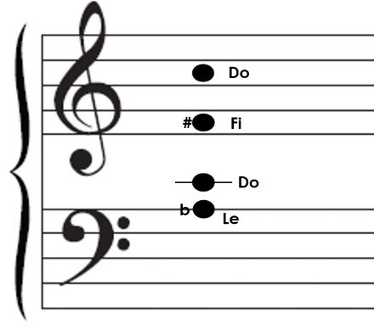
The first type of augmented 6th chord is Italian. Italian augmented 6ths are the only chords in this category that are not 7th chords. In an Italian chord, we still have our base of Le, Do, Fi. The last note that we add simply doubles Do. This example that we have is based in the key of C. Our Le will be Ab, our Do will be C, and our Fi will be F#. Since this is an Italian chord, we will simply add another C to double the Do. Now you have an Italian 6th, which is written as It6 in most instances. The Italian is written this way because it is written in first inversion with Le in the bass.
Figure 1
French
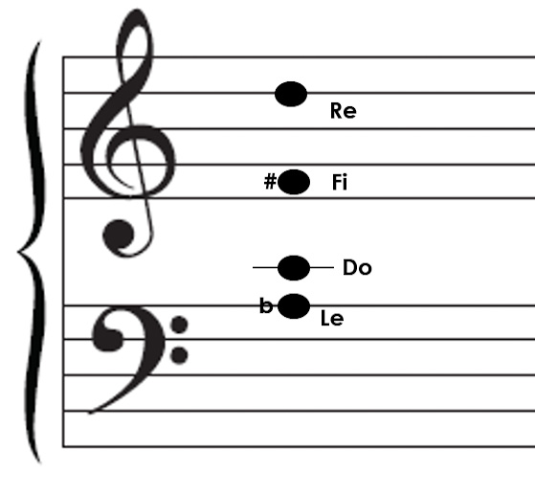
Now let’s go to the French augmented 6th. The French chord becomes a 7th chord by using our base of Le, Do, Fi; however, this time we include a Re. Still using the key of C we will have: Le/Ab, Do/C, and Fi/F#. Our Re will be D. Our chord is now Ab C F# D. Since it is an augmented 6th chord. This chord will be written with Le in the bass again but now it will be in second inversion. Because of this, our French augmented 6th is written as Fr4/3.
Figure 2
German
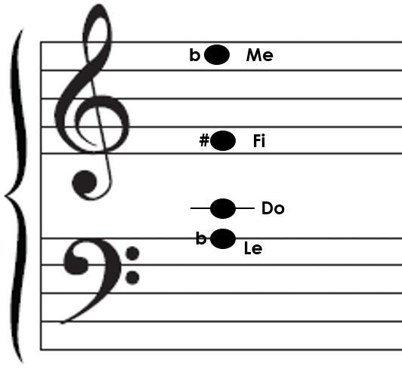
The last type is the German augmented 6th. The German chord is also a 7th chord, but this time we add Me instead of Do or Re. Our chord is now Le, Do, FI, Me which results in a chord of Ab C F# Eb. German augmented 6ths are commonly written as Ger6/5 since the bass will be Le exactly like the others.

Figure 3
Resolving Augmented 6ths
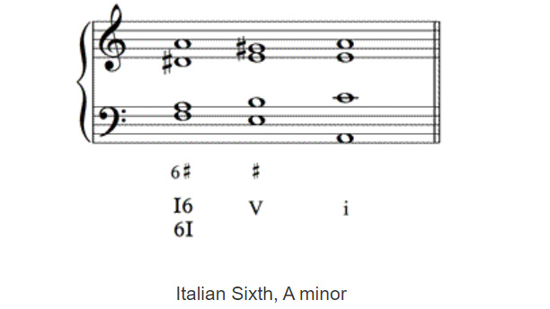
Each type of chord is built differently than most chords, but they still follow our original part writing rules. Augmented 6ths in particular will always resolve to V. Our Italian augmented 6th is simply a triad with a doubled Do. This means that we need to follow our triad rules of no parallels (5ths or octaves), smooth voice leading, and motion contrary to the bass if possible. This example shows how an Italian augmented 6th should be resolved. As you can see, we have lots of stepwise motion in an It6 to V to I progression
Figure 4: (Teoria)
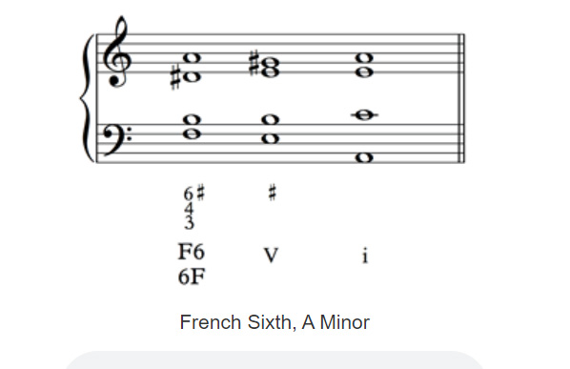
When looking at French augmented 6ths, we now have to remember our rules for 7th chords. The two main rules to for 7th chords are the leading tone always resolves up by step and the chordal 7th resolves down by step. This example shows each part of the chord resolving according to these rules. Notice how we go from our augmented chord to a V chord to our i.
Figure 5: (Teoria)
The most complicated resolution occurs with the use of a German 6/5. The German chord if resolved naturally to a V like the other chords, would create parallel 5ths. Because of this, we have to use a Cadential 6/4. Now we go from a Ger6/5 to a V6/4 to a V. The Cadential 6/4 allows us to resolve to the dominant while first using the theoretical I chord to get there.

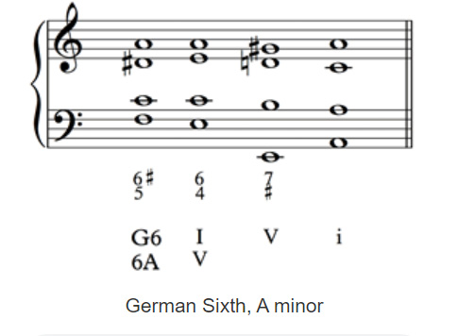
Figure 6: (Teoria)
Outro
Thank you for watching TutorTube! I hope you enjoyed this video. Please subscribe to our channel for more exciting videos. Check out the links in the description below for more information about The Learning Center and follow us on social media. See you next time!
References
Figures 4-6: “Augmented 6ths” Augmented Sixth Chords, www.teoria.com/en/reference/a/augmented-6th.php.

